**Notes on EPSilon Varsity**

**Varsity Robotics**, new to EPS for the 2017-2018 season, is a unique opportunity for highly motivated students who wish to participate on a truly competitive robotics team. There will be no shoddy engineering – no duct tape or hot glue. No memes, and no random wood scraps. There will be documentation, specs, and write-ups for every component attached to the robot. In keeping with this goal, students were asked to apply to the Varsity team by designing, documenting, and building a “tryout piece” of value to the robot. The notes are as follows:

**Applicants** – *All students, with the exception of Aman, applied for an engineering role. Should Aman fail to make the team, Gavin will take over lead programming duties*

* Gavin U
* Sanford L
* Aman B
* Quinn B
* Audrey W
* Sam FK

**Other Roles** – *Students who did not wish to join the team in an engineering/programming role were invited to apply for management positions*

* Henry M – Captain
* Alexandra R – Program Manager
* Rory F – Outreach Coordinator
* Henry S – Spirit Leader

**Application Notes (written by AR)**

***9 March 2017 – Applications Day One***

**Applicant: Gavin U**

* **Design Process**
  + Original iterations had automatic gearshift that would switch gear ratios
    - Too complicated
  + Had difficulty with axle hubs on rollers
    - Originally wanted 3D printed rims (expands when printing, would not hug axle properly)
    - Wrapped layers with tape
  + Initially reluctant to autocad, however, allowed him to discover many problems
* **Features**
  + Lifting robot (holes for hook in tape measure)
  + Can lift 40 pounds (20 at half power)
    - 40 pound weights not accessible)
  + Can increase gear ratio from 4:1 to 8:1(?)
  + Spool has no visible axle hub (hollow, 2 halves, hubs in the middle) --> makes mechanism more compact
  + Curved rollers that curve in the same way as the tape measure
  + Holes placed so that chain is tensed by default regardless of sprocket
    - Can also slide axle forward or back (no such thing as "chain tensed by default")
      * Mr. Mein appears to be extremely skeptical of this feature; CAD-design may be evidence
  + Will it be steady?
    - Yes; tested up to 8ft
* **Feedback & Future**
  + Plans to add a face plate to make sure that the tape measure enters at the correct angle and position
    - Otherwise, hear crunching noises/is misaligned
  + Needs to put collars on the axles
  + Needs to close off on back to help with guidance
  + Connection to robot appears to be sketchy (wood should be thicker)
  + "Default tension" feature needs to be investigated
* **Update**
  + Problem #1 - tape measure was coming out the back --> enlarged oval wheel
  + Problem #2 - cost: $138
  + Problem #3 - spacer assembly tool so that it is the correct width
  + Problem #4 - attached collars

**Applicant: Sanford L**

* Original design similar to robot found online
  + Their swerve can only turn 90 degrees
  + Motors directly attached to wheels
  + Turned by servos
  + This defeats the purpose of the swerve drive
    - 100% power forward, still go sideways
* Design also based off of second robot
  + Cannot effectively turn without friction
* Design uses servo design to turn swerve drive, but chains also turn the wheels
  + Did not directly attach motors to the wheels (AutoCad worked, but wires are a problem; get caught at 360)
    - Requires a more complicated design
* First design had a lot of friction
  + Needed to stop using hubs to directly attach onto wood
  + Started using coper hubs (greatly reduced friction)
* Final design includes wood plate on one side
  + Steel plate for competition
    - Could use CNC'd aluminum plate?
* Still designing version with entire chassis
* Concerns:
  + Bill of materials (cost)
    - One DC turns one wheel
    - Requires 8 servos --> still has to be tested
      * Servos have to be geared (2:1 ratio)
  + Height (?)
  + Chain tensioning
    - 3 small gears? --> amount of torque not well trusted to gears
  + Why should we go swerve over mecanum?
    - Rotating platform, any direction forward, 100% forward power
  + Viability depends on cost
* **Update**
  + Problem #1: Servo is mounted
    - We do not know if it is strong enough; complete freedom of movement requires 135 degrees
  + Problem #2: Cost: $558
    - Need inventory - how many can we build with what we have, and what do we have left?

*Note: Aman B intended to present on this date but did not complete his project in time*

***16 March 2017 – Applications Day Two***

**Applicant: Quinn B**

* **Design**
  + Robotic hand (incomplete)
  + "finger pusher" - worm gear connected to servo, pushes finger up
    - Torque applied by servo: 244 Nmm (at 1mm out from axle, 244 Newtons; 2mm out = 122 Newtons)
  + Hand goes down with force of 58 Newtons
  + Lever attached to base, pulls back part to lift front part
    - Similar system for second shaft --> not enough torque
  + Custom-designed pin/servo bracket --> pin should be glued
  + Teeth on servo push against/wear worm gear
  + Can pick up cubes, small wiffle balls (sort of blue ones, needs better claws)
  + Intended to be on rotating base
* **Feedback**
  + Arm should be bent more downward by default
  + Double thickness of wood
  + Add rubber tips
  + Intended to be on rotating base -> potentiometer (could use motor encoder as replacement)
  + We want to see a curve for radius of inscribing circle of thing, and force with which fingers press on circular object
    - Many factors affect torque - servo, worm gear, fingers --> can be determined experimentally (valuable bc friction loss)
  + Movement mechanism
    - Changing angles of two levers makes for a geometry problem --> something needs to be geared to the axle (DC motor)
    - Could attach second shaft to arm, would be able to change independently (still need DC motor)

**Applicant: Audrey W**

* Mecanum wheels
* First iteration - bigger - plastic touches the ground
* Second iteration - smaller - non-3D printed axles (polished brass tubing)
  + Allows radius of main wheel to be smaller but equally strong
* Works well on mat
* Feedback: estimate cost (weigh wheels)/estimate time
* Need real proof of concept (make 3 more wheels and mount them)
* Are mecanum wheels patented?

**Applicant: Aman B**

* PID control - feedback loop system that relies on the changing values of sensors to create an accurate movement
* P - proportional; I - integral; D - differential
* Normal line-following robot goes straight, left, or to the right. "Proportional" makes it a linear program, so that it only moves minimally to either side
* "Integral" records and accumulates error. It is multiplied by a coefficient.
* "Differential" takes into account the previous error
* Rise time - how quickly it reacts to getting an error
* Oscillation + damping of oscillation (wiggles less) --> PI
* Does it work? Ideally, would follow a white line and freak out. In actuality, it took a long time to get the program running, and all it appears to do is turn in a circle, with occasional wiggling
* Further testing lead to some functionality, but it appears to be inconsistent at best

**Applicant: Sam FK**

* Ball Lifter
* Pulleys on back of lift
* Difficulty with friction between pieces of extruded aluminum and moving slides along them (had to sand them down)
  + Not all parts are 3D printed
* Lifter theoretically folds down and is lifted into place (fit within 18" cube)
* Doesn't actually bend as anticipated - may get stuck on pylons
* Most proud of project design rather than construction/duct tape
* Designed in Autodesk inventor --> has CAD files for all parts
* How was this stuff supposed to be put together?
  + 2 connectors per slide (1 at top, one at bottom) --> ran out of slides that came with the kit, only used 1 per slide (weaker, stopping mechanism doesn't work properly)
* If it were to flip down, he would have a longer piece of aluminum and a hinge that would lay flush with the lift itself, or flat on the piece of aluminum
* Has not yet been tested
* Slides attached by sanding and jamming
* Requires more iterations
* Ball collector slides freely in order to collect ball

*After significant deliberation, the Varsity team was announced as follows*:

* **Henry M – Captain**
* **Alexandra R – Program Manager**
* **Rory F – Outreach Coordinator**
* **Henry S – Spirit Leader**
* **Gavin U – Lead Programmer**
* **Quinn B – Engineer**
* **Sanford L – Engineer**
* **Audrey W – Engineer**

Aman B and Sam FK were invited the opportunity to return to robotics for the 2017-2018 season to join Junior Varsity, possibly in a leadership role.

After further deliberation and some protest, a rule was made regarding rising seniors who had been rejected from the first round of applications. Should they choose to do so, they would be permitted to join the team in a non-primary assistant role. Heading into the season, therefore, the roster is as follows:

* **Henry M – Captain**
* **Alexandra R – Program Manager**
* **Rory F – Outreach Coordinator**
* **Henry S – Spirit Leader**
* **Gavin U – Lead Programmer**
* **Quinn B – Engineer**
* **Sanford L – Engineer**
* **Audrey W – Engineer**
* **Sam FK – Handyman**

The season begins on 14 April, after EBC week and Spring Break. Most, if not all, members are expected to attend. Failure to attend a sufficient number of sessions can and will result in expulsion from the Varsity Team. A high level of competitiveness requires a high level of commitment.

**14 April, 2017 – EPSilon Red 8103**

*Attendance: SFK, AR, HM, HS, SL, GU*

*Missing: QB, AW, RF*

**To-do:** Clean out boxes, disassemble chassis, begin inventory

**Summary:**

Today was the first official meeting of varsity robotics. Certain ground rules were set (mandatory attendance policy, proper documentation standards, organization and other expectations, etc.)

It was decided that all files, designs, and software pertinent to robotics should be uploaded to the shared GitHub folder and that the standard of documentation should, in general, be higher. The rest of the session consisted entirely of finding pieces and sorting by components, which should greatly expedite the tedious process of finding things in the coming season.

**Goals for next session:**

* Finish sorting and begin inventory
* Hash out how to improve chassis (no work will be done on the chassis after game release)
* Designate Varsity and JV parts
* Send parts to Modern Robotics for inventory

**21 April 2017 – EPSilon Red 8103**

*Attendance: AR, SFK, RF, HM, GU, TN, SL*

*Missing: AW, QB*

**To do:** Finish sorting and work on inventory, send parts to Modern Robotics for servicing, begin disassembling chassis

**Summary:**

Today, we continued sorting, organizing, and inventorying pieces. A [spreadsheet](https://docs.google.com/spreadsheets/d/1TkKv4xD9RsuvuqaQ69O_sEI8EaX-SLDehC7UE6WrfVU/edit?usp=sharing) was created and uploaded to the team GitHub and Yammer, cataloguing all current and desired parts. All Core products were found, and a request was sent to Modern Robotics to have them updated and serviced. They were placed in a box, to be shipped ASAP. A meeting was held regarding chassis assembly, and the disassembly of the current chassis began. Certain design flaws were identified, and we hope to resolve them in the coming season.

Protocols regarding tools were solidified and a box was designated for their storage.

*Current Inventory:*

Machine generated alternative text:
Electronics 
Screws 
Axles 
Size 
Item 
Core Legacy Module 
Servo Controller 
Core Motor Controller 
Core Device Interface 
Core Power Distribution Module 
Motors 
Encoders 
Motor Cables 
AndyMark Motors 
Motor Mounts 
Batteries 
Battery Chargers 
Channels 
Size 
416 
288 
160 
96 
64 
Quantity 
& Flats 
2 
3 
2 
3 
14 
2 
10 
6 
10 
2 
Item 
1/2" 
5/16" 
3/8" 
Nyloc 
Other 
Item 
Extruded Aluminum 
Quantity 
350 
115 
150 
Quantity 
6.5' 
To Order 
1000 
Quantity 
Quantity (Channel) Quantity (Flat) 
12 
22 
2 (12) 
6mm D-shape (13cm) 
4.7mm 
Wheels 
4" Omni-wheels 
4" Wheels 
Gears 
Sprockets 
10 
16 
4 
Lots 
Lots 
Lots 

Boxes in red highlight items that we desire (quantities also listed in red)

**Goals for next session:**

* Take all the wheels off the chassis
* Finish sorting/inventorying
* Make sure parts are sent to MR
* Solidifying programming protocol

**27 April 2017 – Freaky Tikis 8103**

*Attendance: QB, AW, HM, SL, GU, AR, HS*

*Missing: RF, SFK*

**To do:** Work on chassis, design circuit board, schedule remainder of Spring season

**Note:**

*Varsity Robotics is a high-level, competitive program. Members of the team are expected to conduct themselves in a much more focused and productive manner than ever before. Scheduling* ***can*** *and* ***will*** *be done. Engineering notebooks will be written* ***while*** *each meeting is in session. Everything will be documented and accessible to all members of the team. In short,* ***organization is critical to the success of the team.*** *We live and we die with this notebook.*

**Summary:**

**Schedule**

Starting this season, a clear schedule of goals and goal-dates is required in order to keep team members accountable and aware of deadlines. That being said, a buffer of one week has been added should something go horribly awry. Autonomy on the team is a must – members should, and do, know what needs fixing.

|  |  |
| --- | --- |
| 4/27 | Design circuit board layout |
| 5/5 | Build chassis (80/20) and design appx sensor layout |
| 5/12 | Finish chassis and attach sensors |
| 5/19 | Programming day! Stare at Gavin – Mr. Mein is providing popcorn |
| 5/26 | BUFFER |

**New name?**



Team 8103 has been rebranded! Welcome to the new, better-than-ever, 8103 Freaky Tikis! (let the record show that the name was conceived by AR). In the interest of a more productive and competitive team, we are going for a *complete* rebranding – new shirts, jackets, hats, necklaces, and more! Our Spirit Leader, Henry Samuelson, has been working on a logo design (as seen to the left), which we hope to print on our brand-new hats, to accompany our Hawaiian shirts and varsity jackets. The Spirit of the Islands has truly blessed team 8103. *(Pending approval from our Dean of Students)*

**Hubs**

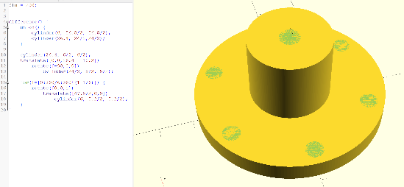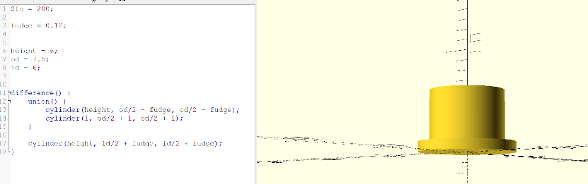QB designed two bushing sizes in OpenSCAD, “small” and “big”, as shown below.

**Chassis Design**

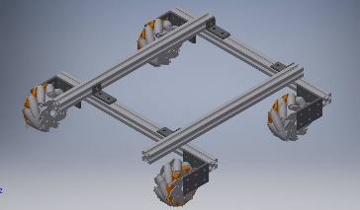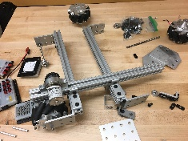SL designed a rough model of the chassis Autodesk Inventor (to be updated with metal plates and motors/motor hubs as soon as possible 🡪 have been added to CAD parts library), as shown to the right. Said pieces are being designed by AW, and should be completed before the end of the session. The chassis is currently entirely disassembled, with the stipulation that we will have a programmed and drivable chassis by the end of the Spring trimester. As you can see based on the picture (to the left), there is still quite a lot of work yet to be done.

**Circuit Board**

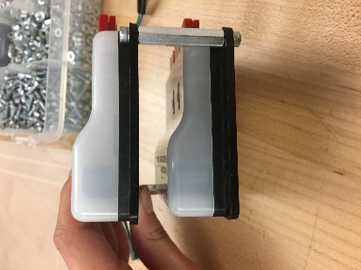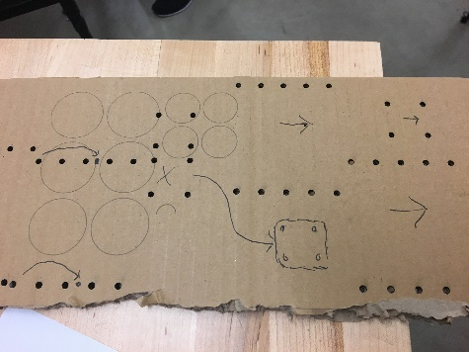GU worked on designing a working and not terrible circuit board. In the past, we’ve tried and failed to design removable, easily accessible ways to access our electronics. Ideas include stacking them on top of each other (see right) and laying them out as shown (see left). Unfortunately, our electronic components are being shipped to Modern Robotics for updates and servicing, and probably will not return for another 8-10 business days.

**Part Shipments**

* 80/20 set to arrive next Wednesday (5/3)
* Axles set to arrive next Tuesday (5/2)
* Electronics should arrive within 3 and 4 business days

**Things to Order**

* [Accelerometer and compass](http://modernroboticsinc.com/compass)
* [6 Andy Mark Motors](http://www.andymark.com/Motors-s/260.htm)
* 5/64” Allen keys
* Two part-extension kits (should have flats and channels)
* [MR-360 IR sensor](http://modernroboticsinc.com/ir-locator-360)
* [MR 2-part ODS](http://modernroboticsinc.com/range-sensor)
* [Collars](https://www.amazon.com/BQLZR-Metal-Bushing-Stainless-Sleeve/dp/B01LQ3LGAM)

**Miscellaneous**

The 80/20 can be cut by Dr. Whitmer. It will be shipped to Mr. Mein’s house; he can bring it to EPS Thursday, and give it to Audrey or Dr. Whitmer – arrangements will have to be made beforehand with either of the Whitmers. Ideally, enough pieces would be given to us by Friday so that we can start redesigning the chassis. Unfortunately, we needed to order new 80/20 because our pieces were not long enough, meaning that the robot was not maximizing the space that it was allowed. To be fair, in the past we have had difficulty in fitting within the sizing cube, but do not expect that to be as much of an issue this season due to our capability to make 3D models before actually building any components.

It should also be noted that, in addition to designing a logo (in progress), HS also worked on customized “Freaky Tiki” name tags. HS and HM will discuss the team’s new name and theme with Dean Hagen ASAP.

**Post-Meeting Brief**

* Audrey – added to CAD library
* Quinn – bushings, and also mec bushings
* Sanford – chassis design
* Gavin – circuit design
* Henry S – worked on new logo design and nametags

**Goals for next session:**

* Decide on Accelerometer/Compass – ideally by Friday 4/28
* Work on chassis – hopefully, 80/20 will have arrived

**5 May 2017 – Who Knows? 8103**

*Attendance: HM, RF, GU, HS, AR, SL, SFK, TN*

*Missing: AW, QB*

**To do:** Circuit board -- CAD Design -- (GU), chassis (SL, SFK, HM), Outreach (RF)

**Summary of Week:**

* Aluminum has arrived and has been cut by Dr. Whitmer (17.5” across the board)
* Axles arrived, but were 6.5mm rather than 6mm. They do not fit and have been returned. New axles have been ordered
* 6 Andy Mark motors with encoders have arrived and been unpackaged
* On Wednesday, HM and SL began work on the chassis. Notably, 10-hole extruded aluminum plates (pictured below) were drilled in order to replace last season’s sketchy supports.
* HS has yet to consult PH regarding the team.

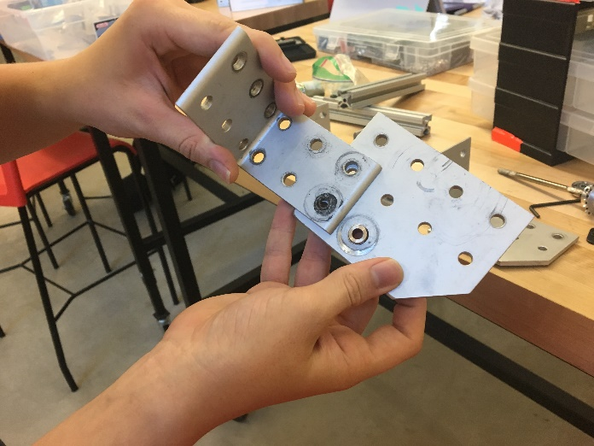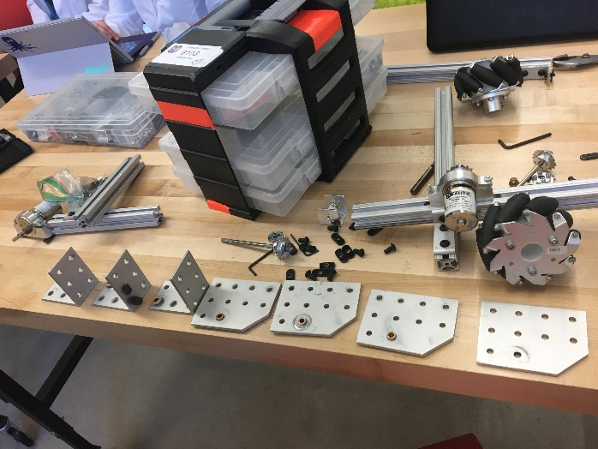

**Chassis**

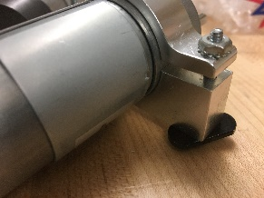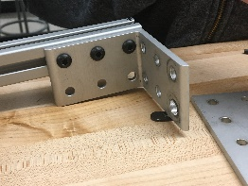 Our old motors were removed from motor brackets and motor brackets cleaned. Most of them are scraped out, which shouldn’t pose too much of a problem. We noticed that our old 80/20 pieces had lines running down their bodies, while the new ones do not. This is useful in that it makes them easily differentiable from one another, which is a good thing because our old pieces were pretty bad. It was decided that we wouldn’t put screws in every hole – only as many necessary for it to be secure. Obviously, the chassis should be as secure as possible (ie, all holes filled), but ultimately putting screws in all of them makes it difficult to remove attachments. Having made these decisions, HM and Sl began to construct the chassis. The 10-hole plates and connecting pieces were attached to the 80/20 (see image) in order to connect the 17.5” 80/20 pieces together at 90 degree angles. Additionally, connecting pieces were attached to each of the four corners of the chassis in order to connect the mecanum wheels. Although we don’t yet have our new axles, one axle and wheel were attached to the robot. All motors were attached to brackets and all brackets were 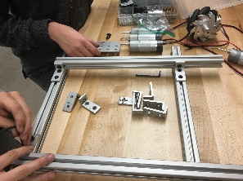attached to 80/20 connection pieces. Motor wires will be put inside of the t-slot.

There was some concern that the current chassis would not be functional, as a bar in the back was flipped and the design was similar to last year’s. Assembly was halted, as the mentors want a CAD design and full review. In the interest of making more room in the front, it is possible that we will move the front bar back and cut last year’s aluminum into pieces to attach the wheels.

**Circuit Board**

Gavin worked on a CAD design of the circuit board. It was decided that motor controllers will be stacked to conserve space (similar to the design from last week).

**Programming Decisions**

Henry Samuelson was proposed as backup programmer. Sam FK is third in line. A meeting was held with the programming team regarding sensors and required autonomous programs. We decided to purchase a gyroscope, accelerometer/compass (although we haven’t decided which yet), a camera that we hope to aid with color sensing, and bottom-facing color sensing should that fail. We would also like an I2C, two touch sensors, and ultrasonic distance sensors. By the end of the school year, the programming team hopes to complete a functional tele-op program, ideally better than last years and with multiple modes for precision and quickness, as well as proper encoders. We would also like autonomous routines for *x* distance in direction *y* degrees, a *y* degree turn, and alignment of a certain side to a wall of distance *z.* We would also like to install a red/blue toggle switch that will trigger the programs for whatever alliance we are on, so that we don’t have a ton of programs.

**Other**

The team mentors made a few decisions regarding the team. We want to push the use of SolidWorks – specifically, we will procure portable licenses and AW will work on understanding how to import the Tetrix library. AR will be in charge of all ordering moving forward, and has been given the information necessary to do so. HM will either get us to CNC aluminum by the end of the 2016-17 school year, or not use it at all. A small bandsaw will likely be purchased.

**Post-meeting Notes**

* SL and HM – what stands in their way? Good engineering
* RF worked on Outreach – what stands in his way? Work ethic
* SFK – debated with Gavin re stacking circuitry, discussed programming
* AR – took notes
* GU – diagrammed circuit board
* Future (summer) meetings – make-up finals, the following week(?), reasonable times, teams starts practicing four days/week on August 23rd

**Design Review Notes**

*(in format* ***Part of Robot****, features)*

Back

* Clear acrylic covering electronics
* 2” 3D printed spacer

Upwards Bars

* Six-hole 80/20
* Outside vs. slightly more outside
* Modularity

Circuitboard

* In the back

Wheels

* Olives go in

Balance

* Counterweights
* 80/20 vs tetrix

Brackets

* Two per joint

New wheel casing

* Move back?
* Cut old 80/20 two to ten cm

**11 May 2017**

*Attendance: SL, SFK, HM, AR, GU, TN*

*Missing: AW, QB, HS, RF*

**Chassis**

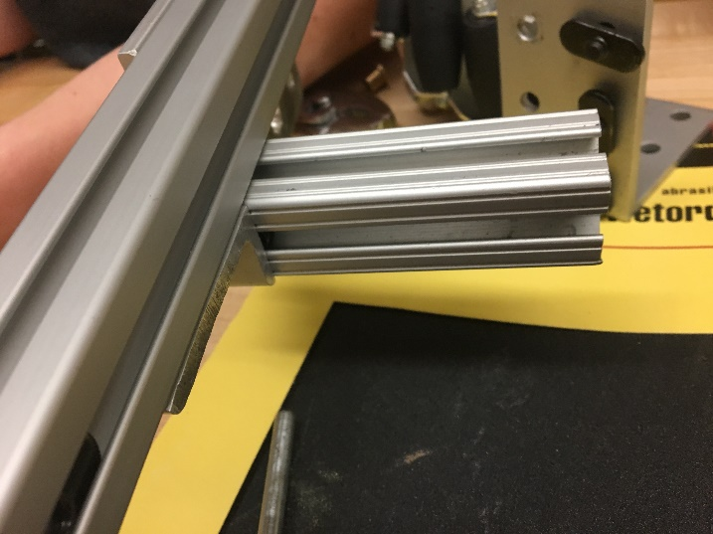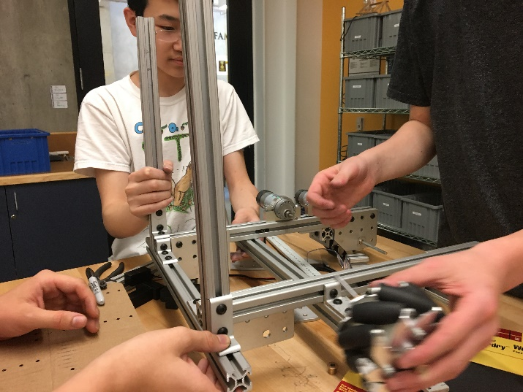

Originally, we assumed that the axles were too big for the wheels, and ended up shipping our old axles back. However, we managed to get them to fit by chopping off the ends and sanding them down, which is an unfortunately time-consuming process. After that was complete, we attempted to attach the wheels to the robot, only to realize that we had done it backwards. We thus had to remove them and reattach them, and by the end of the day had attached all four permanently, including motors and chains. Additionally, the front bar of the chassis (which was originally near the front of the chassis, at about the 16” mark) was removed and replaced further back, in order to allow room for modules in the front. Smaller pieces of t-slot aluminum were attached to the front wheels where the front bar had once been holding them. Four longer pieces of our old t-slot aluminum were attached as posts at each of the four corners of the robot

**Electronics Board**A cardboard model of the future electronics board was printed, and it was determined that it would work properly. The circuit board slides between the two back posts and the electronics are attached to it. Further testing is required with the actual electronics in order to make sure everything fits. Between now and the time the electronics arrive, modifications will likely be made to the original circuit board design.

**Post-Meeting Notes**

* SL – made the axles work, attached a chain
* SFK – attached 2.5 wheels and crossbar
* GU – finished and cut circuit board in cardboard, it works

**17 May 2017**

*Attendance: AR, SFK, SL, HM, GU*

*Missing: AW, QB, HS, RF*

**To do:** Finish as much of chassis as possible, test model electronics board

**Summary:**

**Chassis**

We reattached the last wheel to the axle, which is already starting to break. Having largely completed the frame of the chassis, we then tried to fit robot into our sizing cube, which is slightly larger than it should be, making it difficult to ascertain the size of our robot. We did this primarily because we did not want to continue with adding components to the robot if it is fundamentally too large. We found that it fits in the cube properly if we angle it correctly, as it is approximately 17.5” by 17.5”. However, the engineering is not of great quality, as some of the angles are not ninety degrees. In order to accomplish this, we took a component that had sides at ninety degree angles and aligned it with the bar in the middle of our chassis, and then adjusted it based on those lines. Having completed this, we discussed team strategy and the previous season with a former member of the team, who had come to visit. He provided some insight on chassis design and critiqued our previous chassis. We hope to use his input in the future. After this discussion, we zip-tied the loose motor wires to the 80/20 so that they stayed inside the slots, and tightened all the components of the robot.

**Second Chassis**

We were provided with ½ scale mecanum wheels with which to make a test chassis for programming purposes. We initially wanted to make the chassis ½ scale, but discovered that we may run into problems with gearing ratios and motor power, as we aren’t sure if the programs will translate if the chassis is fundamentally different. Regardless, GU began work on the new chassis. The frame should be completed by next session, and the rest of it will be completed when the power modules arrive.

**Updates**

As the “Freaky Tikis” moniker was denied by our Dean of Students, we have decided to move in a different direction. HS spent a portion of the period coming up with possible names for the team (animal alliterations were quite popular). However, after voting, we eventually ended up deciding on the name “null”, with possible robot names “NaN” and “void”. T-shirts, jackets, and other identifying merchandise should be purchased shortly.

Our power modules were recently shipped to Modern Robotics for reservicing. We received a confirmation email that they had been received and paid the fee. Modern Robotics indicated that the modules would arrive within two days, and should therefore be here by Friday, 5/18, as we were informed that they shipped today.

**18 May 2017**

*Attendance: AR, HM, SFK, AW, GU, SL, RF, HS*

*Missing: QB*

**To do:** Figure out what to order (SL), assemble second chassis (SFK, GU), work on design (AW), CNC dry dock (HM), formulate outreach program (RF)

**Design Elements**

Sam FK spent the day making an Inventor file based on the Inkscape file of the circuit board that Gavin sent him, in order to place it on the final design file of the robot. Audrey printed another mecanum wheel. Henry Samuelson researched aluminum, in order to find the best quality parts, as demonstrated in the chart below.

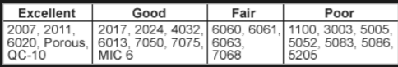

**Second Chassis**

We are building a second chassis in order to test software while the rest of the team focuses on the hardware of the first chassis. This has largely been Gavin’s project, as he is the lead software engineer. Unfortunately, he put the wheels on wrong, but he thinks that he can “save” it (ie, not completely restart), possibly by moving motor brackets around.

**Purchases**

Sanford spent most of the day assessing what new parts the robot would need. Eventually, with suggestions from Dr. Whitmer and approval from most of the team, we decided on the following:

* 8 L brackets
* 96” T-slot aluminum
* 200 nyloc screws

**Shields**

The final dimensions for the shields are as follows:

* Side: 13.75”
* Back: 13.5”

**25 May 2017**

**Design Elements**

Sam FK is continuing his work with turning the Inkscape file into an Inventor file, and 3D printed spacers (essentially washers with more thickness). He also tightened all of the set screws on the robot. The shield on the robot that slides down was attached, and a drydock was constructed, although there is a knot on one end that could be a problem in the future, and has already nearly broken the robot, as it was not properly docked.

**Battery**

All of the battery chargers were checked, and one is no longer functional. We also found that only three motors on the robot run properly, which could be a problem.

**Test Bot**

Dr. Whitmer brought in his test bot, to show us, and ours was disassembled.

**Programming**

Thanks to Gavin, the robot’s wheels can now move and be controlled by the controller.

**Outreach**

Rory has various ideas for our new outreach program, including mentoring our school’s FLL team. However, we as a team also accept the challenges we may face in outreach, as many other teams have established programs and ours could take a few years to develop. As a team, we also acknowledge the problems we may have in raising funds.

**26 May**

*Attendance: All present*

**Programming**

At the beginning of the session, the robot could only drive one way. However, after some time, it was fully functional from a movement standpoint and ready for trials, which were to be used to determine next season’s drivers.

**Design Elements**

Sam FK redesigned a thing he did not make that everyone was impressed with. Would have a gotten a promotion if he learned how to take credit for other people’s shit (it is a part that fits into the t-slot and allows for attachments)

**Second Chassis**

Now that Audrey and Quinn have returned from prior commitments and are fully focused on robotics, they have been given the task of redesigning and rebuilding the practice chassis.

**Drive Test**

* 30 second trial period
* Stand at one end of the room
* Robot starts at tape mark
* Go outside and around chair-cones and to the end
* Time penalty for hitting obstacles

|  |  |
| --- | --- |
| **Participant** | **Time** |
| Audrey |  |
| Quinn |  |
| Henry M |  |
| Henry S |  |
| Sanford |  |
| Julian talking to Mr. Mein | 00:41:42 |

Attempts at drive trials hindered by the robot continually stopping. We suspect there may be an issue in connecting to the phone

**16 June**

After a significant break from robotics, due to finals and other circumstances, the available portion of the team met again. (AR was not present to document due to prior obligations).

During this time, the shields were attached to the robot, the motors were moved inwards, the prototype phone holder was removed, and the cables were managed in such a way that they would have some degree of neatness.

**Goals for August 23rd (start of season):**

* Battery mount
* Permanent switch location
* Back shield
* Permanent cable management
* Permanent motor controller mount
* Front phone swing mount
* IR sensor location mount
* US sensor location mount

*(note: AR transcribed this from an image and was not present for the meeting; thus, all interpretations of handwriting were solely her own and may not reflect the intentions of the team – will likely return with revised goals on 23 August)*

**28 June**

**Gavin’s Software Update (from Home)**

Week 1 robot software update - compass + relative drive complete.  
  
Over the past week, I've worked to finish the relative drive software for the robot (similar to what we had last year), and to develop the required software to make use of and test our new compass sensor. Unfortunately, my family was away for Saturday, Sunday, and Monday, and when combined with my internship last week I did not have a lot of time to work on robot software. Nevertheless, below is a list of what I have accomplished.  
  
- Compass sensor  
- Determined that compass is extremely finicky, and often gives outlandish values when used  
- Discovered that the magnetic fields generated by the motors render the compass unusable when wheels spin  
- Wrote automatic compass calibration software (found in the autonomous opmodes section)  
- Wrote software for combining values obtained from the compass and gyro sensors into a single, reliable number that does not drift over time  
  
- Finished relative drive software  
- Discovered the bug that plagued me while I was working on this software before school ended  
- Added a slow mode that reduces robot speed in variable amounts controlled by the trigger  
- Implemented the above compass sensor software to ensure that my heading locking code does not drift over time  
- Adjusted wheel speed generating code and compressed it down to half its original size  
- Adjusted parts of wheel speed generating code to allow the robot to rotate while in motion  
  
For next week, I will build the nonrelative (god-direction) teleop software, and will hopefully learn how to use the two color sensors and build simple line-following software. All the code mentioned above is well commented and is available at <https://github.com/guberti/ftc_app> (I need to move this to the EPS Github account at some point).

**Update from 29 June:**

Robot is holding up remarkably well to my software testing! I've driven it every day but one since I took it home 10 days ago, and today is the first day I've had to tighten the set screws on the wheels. Nice job hardware team!

**22 August 2017**

*Present: GU, SL, HM, SFK, AR, QB (late)*

*Absent: RF, HS AW (CW) – Excused*

* Game reveal – 9 September (after overnights)
* Calendar moved up – Event One is 1st week of November
* Event Three is right before Winter Break – everyone should talk to their parents before the next meeting
* Fall Break (September 20th/21st) – Do we meet or not?
* By the end of the day, ideally a single “Varsity Robotics” shelf to ourselves
* ***Every time a component is built, HAVE A “REVIEW” ***
* “We’re doing away with some of the old rules and adding on new ones”
* We will meet before we cleanup
* Well named files in a public space with iterations clearly versioned

Agenda:

* Discuss electronics, shields, and integrity
* Standard Parts
* Phone Flipper
* Cable making/Management

Parts we should design:

* Sensor mount

Projects

* Phone flipper
* People picker upper
* Lift

Things to buy

* Acrylic solvent
* D clips
* Irrigation tip squeeze bottle with needle
* aluminum
* FK – worked on soldering distance sensor
* Organized github files
* Tomorrow: discuss shields & “thing”